Week03 - Testing Database

SQL to check the tables

EVIDENCE REQUIREMENT

1. A COPY OF THE SQL CODE THAT COMPLETES EACH OF THE REQUESTED QUERIES
2. THE OUTPUT SHOWING THE RESULT FROM RUNNING THE QUERIES – USE SNIPPING TOOL TO SHOW THE OUTPUT

Q1. Check that each table will display the output presented in the individual tables

Select *

From customer;

Select *

From staff

Select * from

Item;

Select * from

Menu;

Select* from

Order_id;

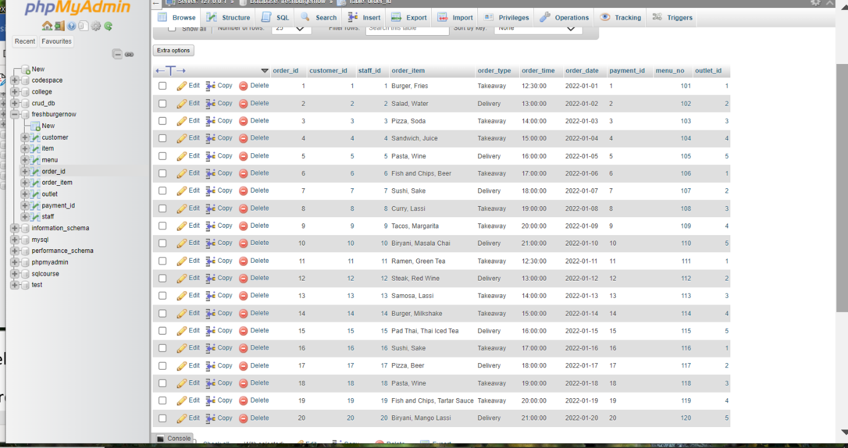

Select* from

Order_item;

Select * from

Outlet;

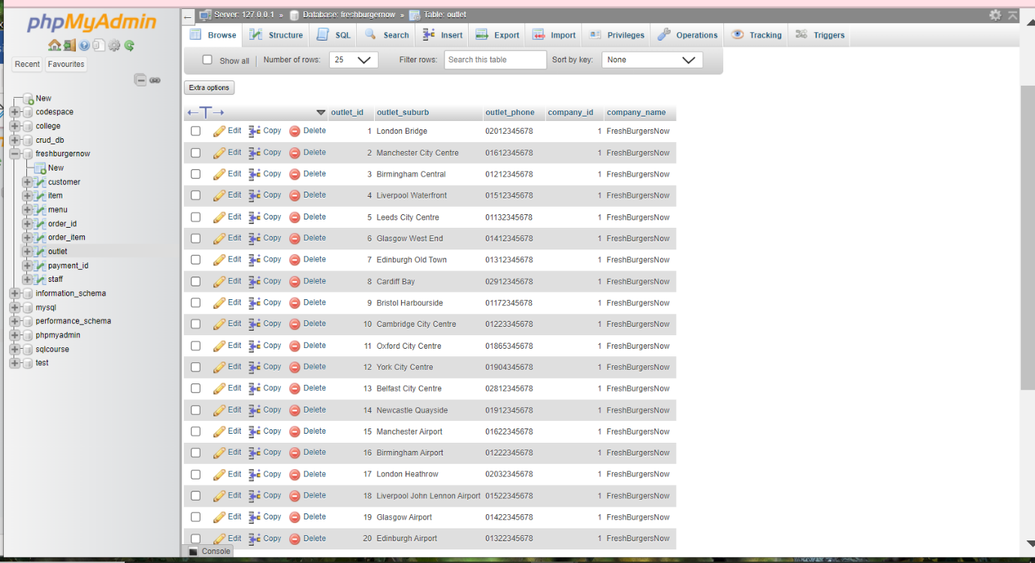

Select * from

Payment_id;

Q2. Show the output from two of the adjacent tables in turn – that is order and customer; staff and order.

SELECT order_id*,customer.*

FROM order_id order_id

INNER JOIN customer customer

ON order_id.customer_id = customer. customer_id;

SELECT *,staff.*, order_id*

FROM staff staff

INNER JOIN order_id order_id

ON staff. staff_id = order_id. staff_id;

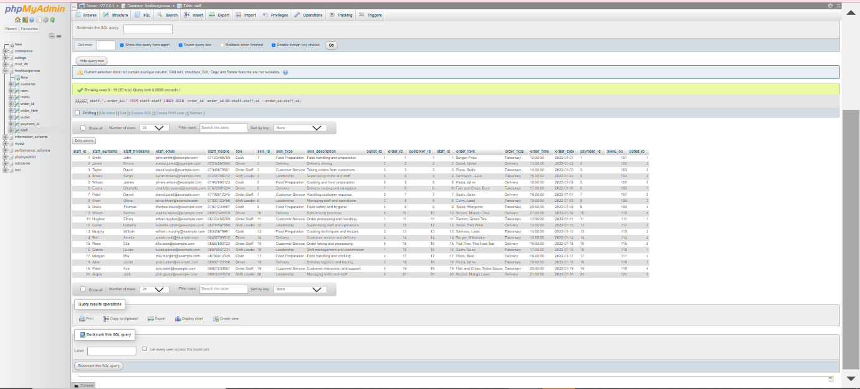

Q3. Connect all three tables and display the output that shows the output from these three tables – customer, order and staff.

SELECT customer*,order_id*,staff*

FROM customer customer

INNER JOIN order_id order_id

ON customer. customer_id = order_id .customer_id

INNER JOIN staff staff ON order_id. staff_id = staff. staff_id;

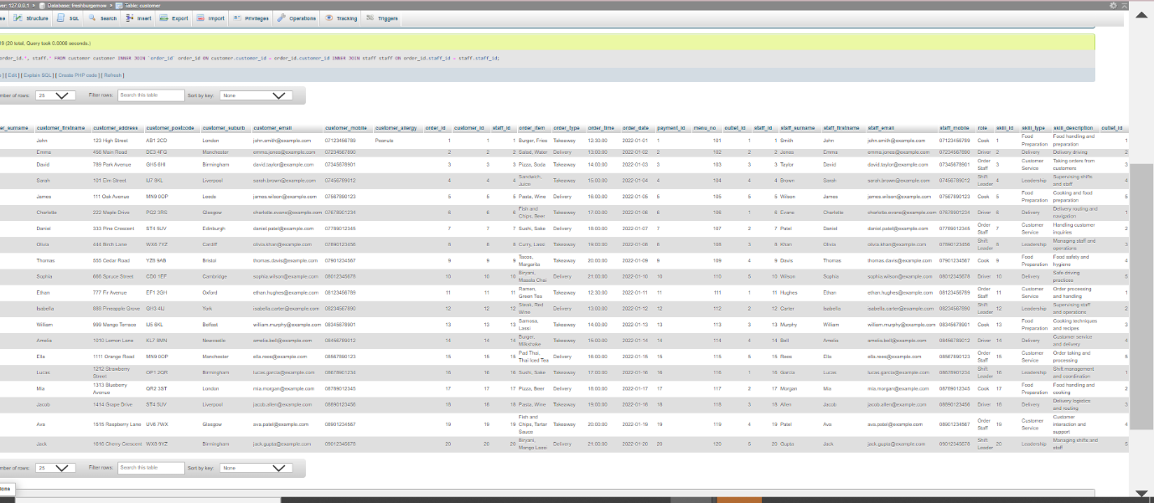

Q4. Create a query that will show the customer and payment – so link these two tables and produce the output.

SELECT customer.*,payment_id.*

FROM customer customer

INNER JOIN payment_id payment_id

ON customer. customer_id = payment_id. payment_id;

Q5. A manager wants to show a catalogue of the items in the system and their quantities.

SELECT* FROM item;

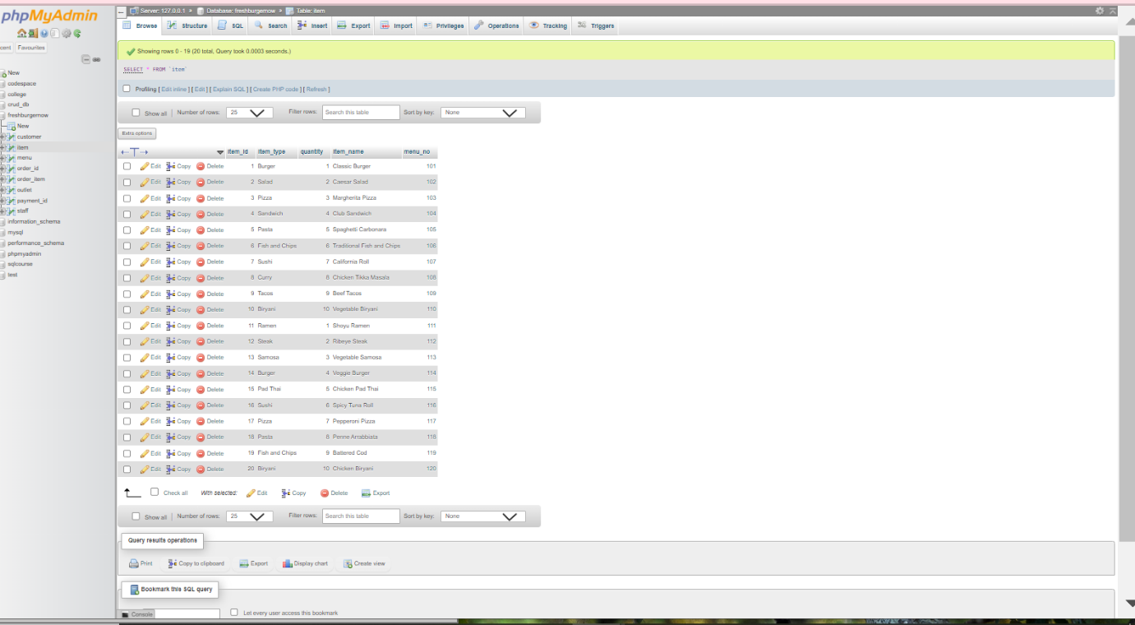

FreshBurgerNow Diagram(Designer).

